# Car Detection using Mask-RCNN using pre-trained model and Open CV

**Agenda:**

1. Use OpenCV Selective Search to simply detect Car using VGG16 model
2. Use Mask-RCNN + COCO weight to detect car using ResNet101

**Data Set:**

**https://www.kaggle.com/datasets/sshikamaru/car-object-detection**

Total Number of Sample: 1001

Training set: 500 (annotated)

Validation Set: 59 (annotated)

Testing Set: 175 (Unannotated)

**Sample Data:**

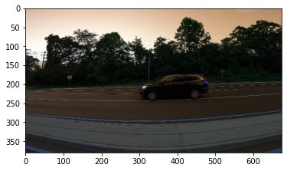

**Annotated data: Data annotation done by manually**

../input/car-object-detection/data/train_solution_bounding_boxes (1).csv

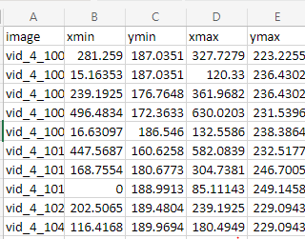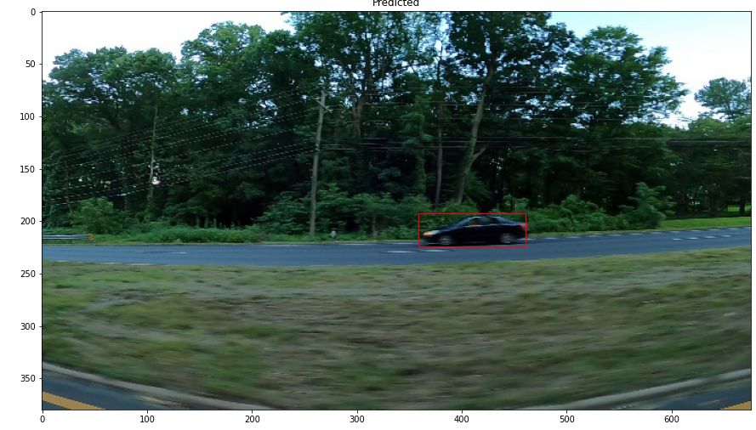

**Source Code:**

1. **Importing and Installing libraries**

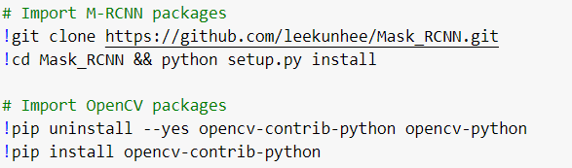 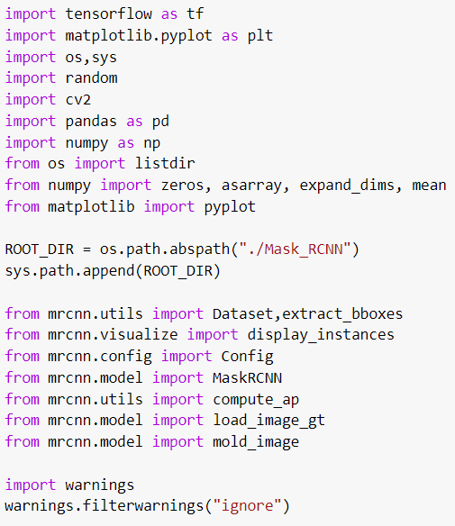

1. **Load dataset**





1. **Preprocess the annotated data**
2. **Split the data into train and validation set**

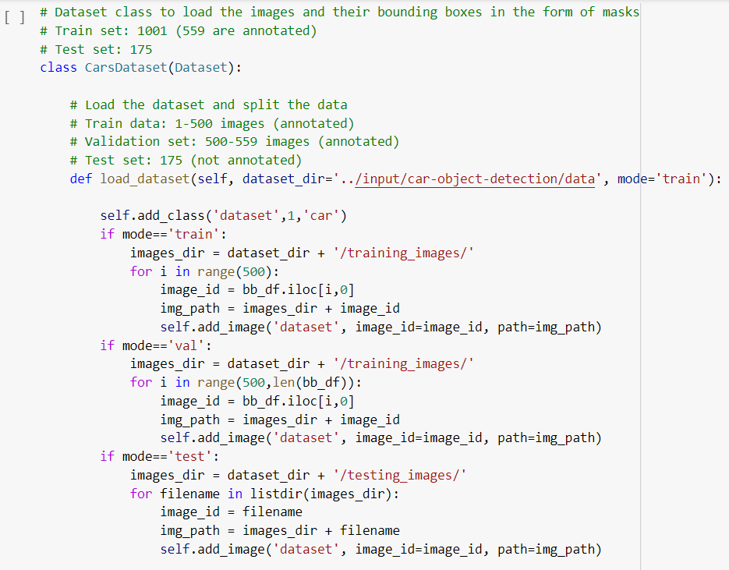

1. **Prepare Bounty box from annotated co-ordinates data**

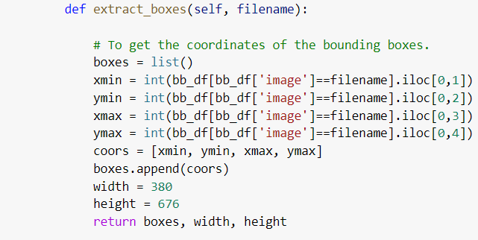

1. **Prepare Mask from annotated co-ordinates data**

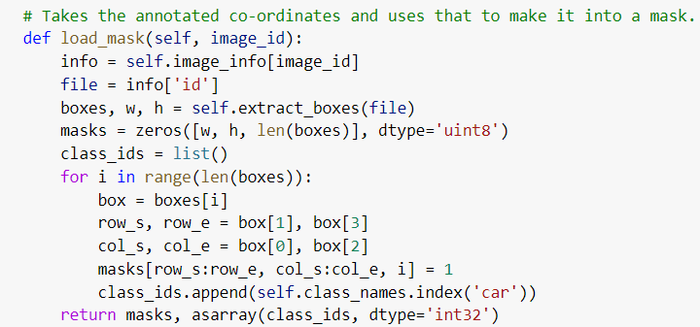

1. **Visualize a mask**
2. 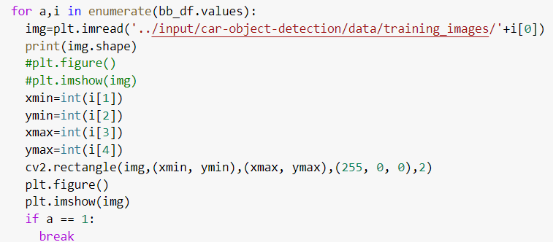**Visualize using Open CV**

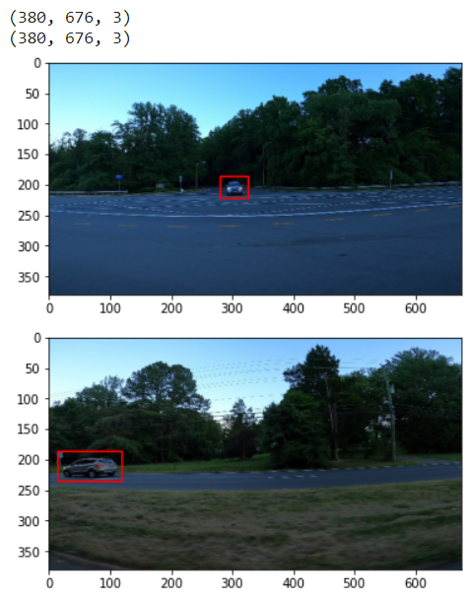

1. **Visualize using Mask-R CNN package**

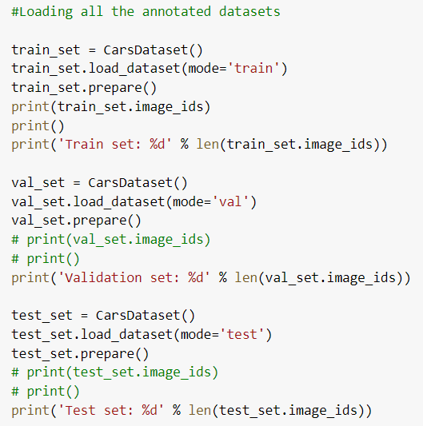 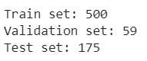 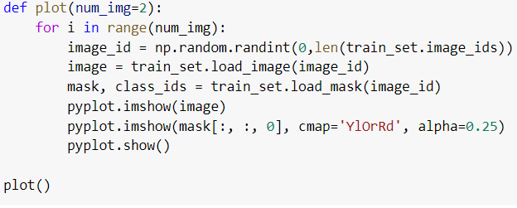

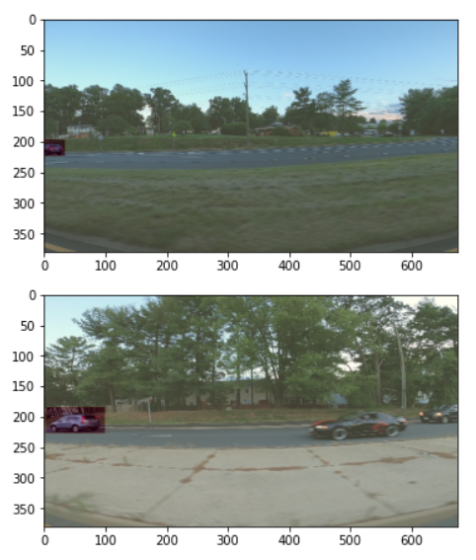

1. **Prepare Mask to fed in Deep Learning models**
2. **Using Segmentation and Selective Search for Feature Extraction using OpenCV**

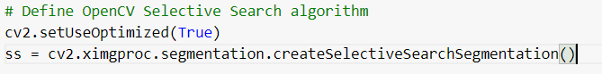

**Test the Masking Search algorithm**

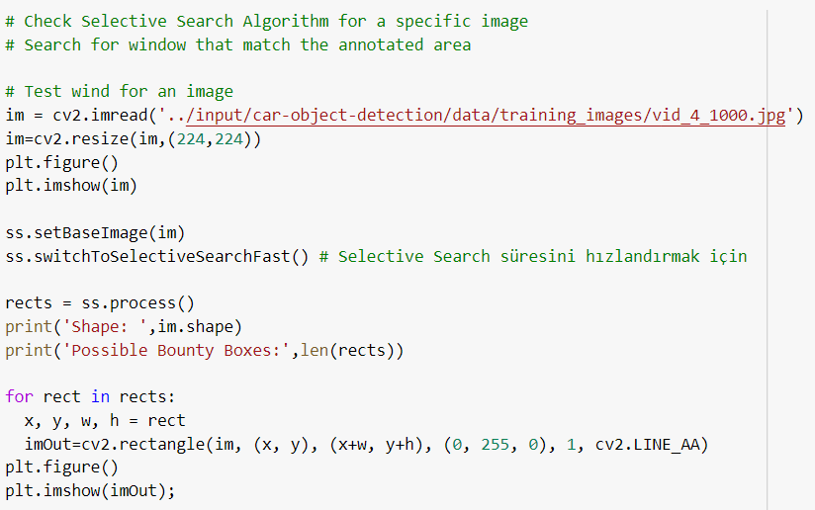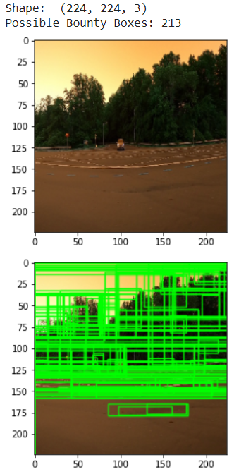

**Prepare masking accuracy using IOU**

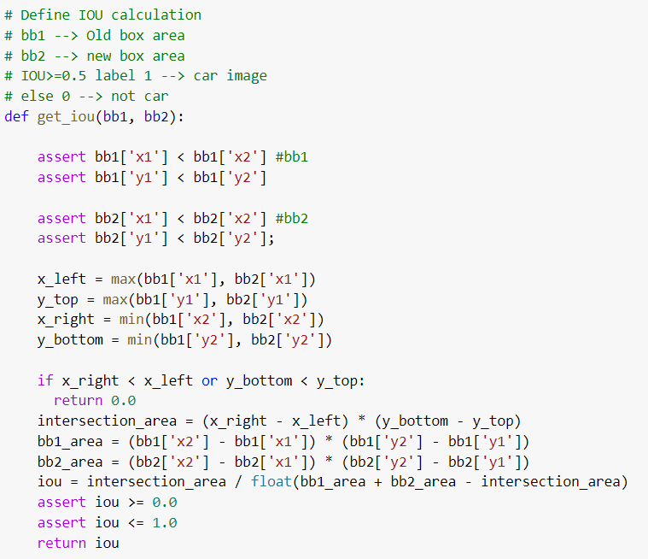

**Assign label for correctly masked image**

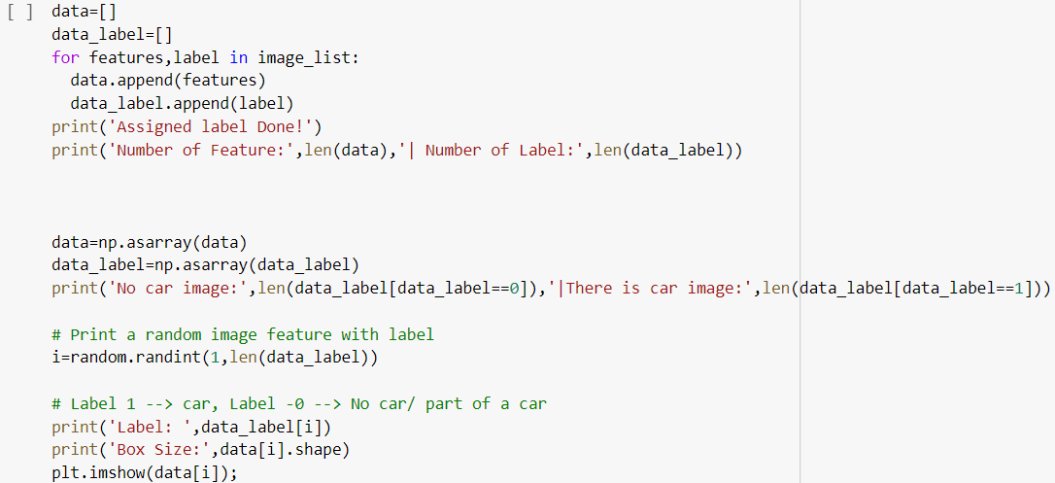 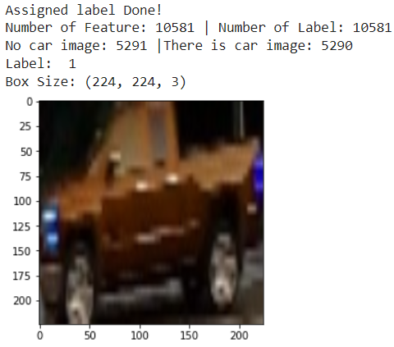

1. **Configuration setting for Mask-RCNN and ResNet101 Pretrained Configuration**

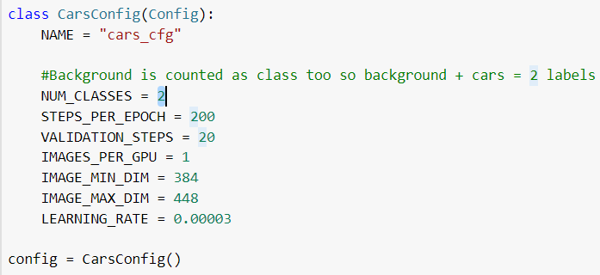  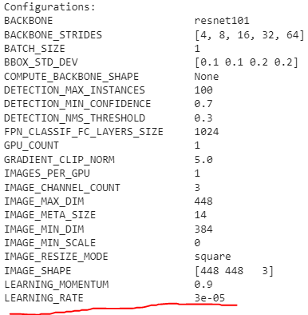

**Apply Mask-RCNN packages**



**Load COCO weights**



1. **Define Deep Learning Models**
2. **For Open CV approach: Define VGG + ImageNet weights**

 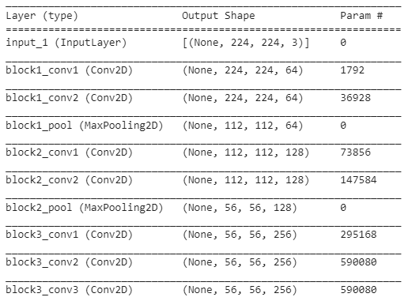

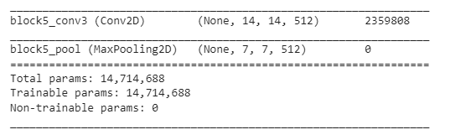**Define Extra layer for pretrained model**

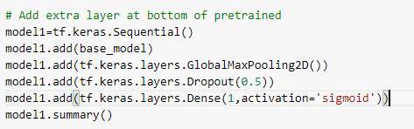

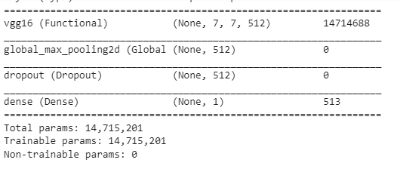

**Freeze the base layer**

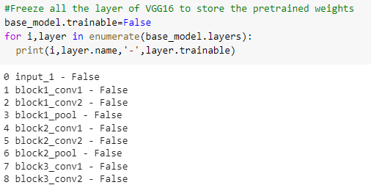 

1. **Define ResNet 101+ COCO weights for Mask-RCNN**

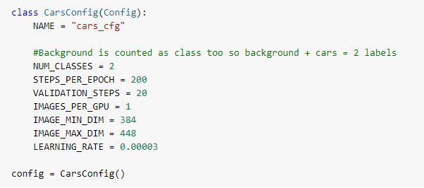

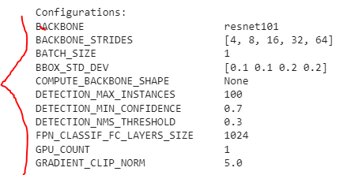

**7. Train the model**

**a) VGG16 + ImageNet weights**

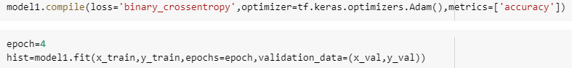 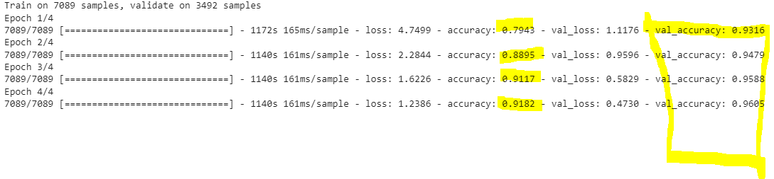

**b) ResNet 101 + COCO weights**



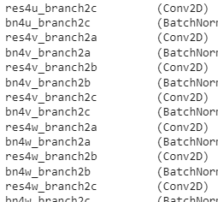 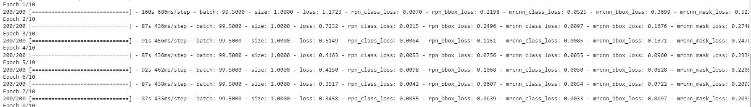 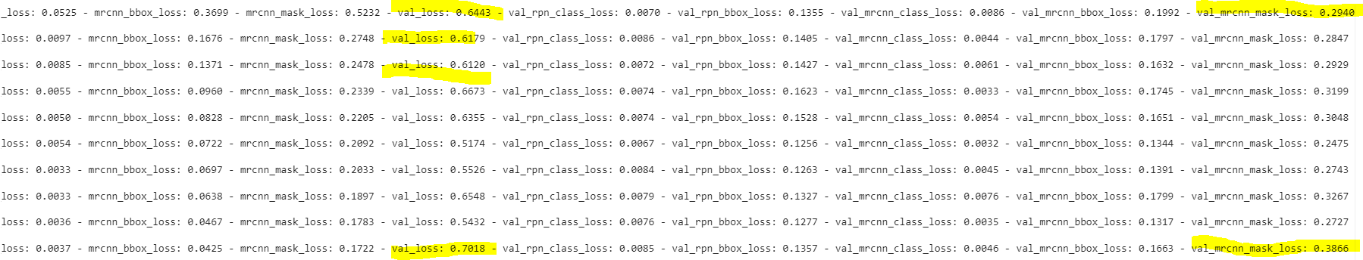

1. **Evaluation**
2. **VGG + ImageNet: Model accuracy + IOU window**

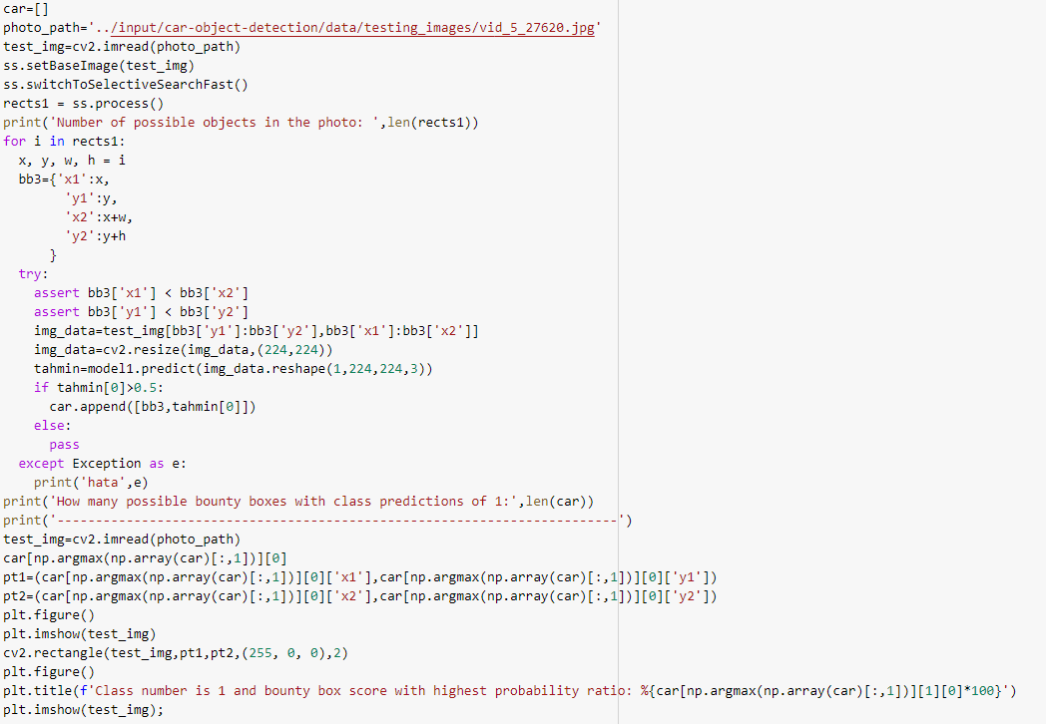

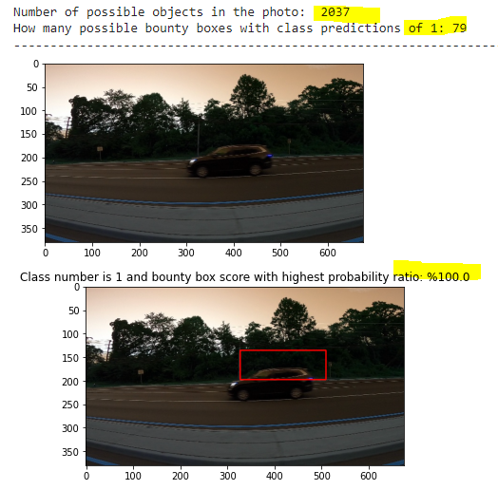

1. **Mask-RCNN ResNet101 + COCO weights: MAP evaluation**

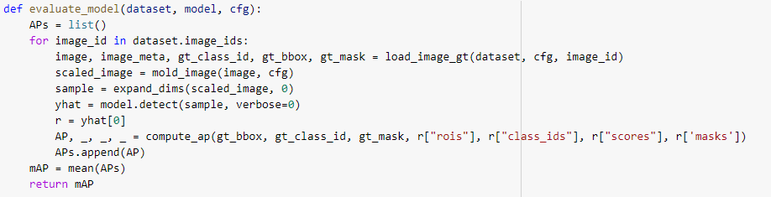 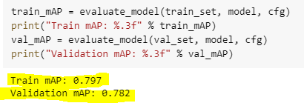

**Compare Some Samples**

